## Product Requirements Document

Project 2:

Animal Shelter Management System

*ENGI-3675 WA  
Database Systems*

*Group 2:*

* Slim Babay (Project Manager)
* Robert Byrne (Developer)
* Antoine Starvo (Quality Assurance)

**Objective**

This objective of this project is to create a web solution to manage animals for an Animal Shelter that works in Chrome (v39) and Internet Explorer (v11). This will be implemented by a CRUD interface in ASP displaying a dynamic table that would allow a user to insert or delete animals and to update the attributes of existing animals. The solution should be resistant against injection attacks by implementing prepared statements and produce a web solution that adheres to w3 HTML5 web standards.

**Design Mockup**

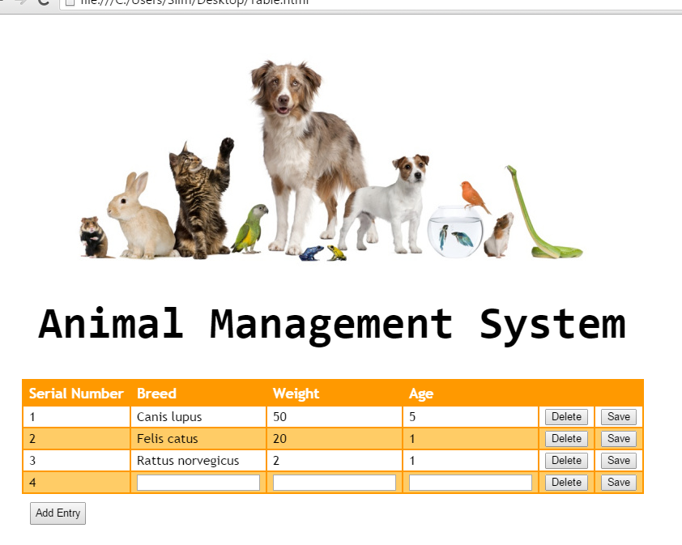

**Data model**

Each animal will be represented by an entry within the table with the following attributes:

* Serial_Number (integer/primary key)
* Breed (text not empty)
* Weight(float/real) between 0 and 500
* Age(float/real) between 0 and 100